A picture tells a thousand words
Applied Economic Exercise
www.economicstutor.com.au

Observe each of the charts below and attempt to draw out the implications for the economy and policy settings. The first has been done for you to provide an idea about an approach that could be used. The charts have been sourced from either the August edition of the RBA’s Charts Pack and/or the August Statement on Monetary policy, both of which can be accessed here https://www.rba.gov.au/

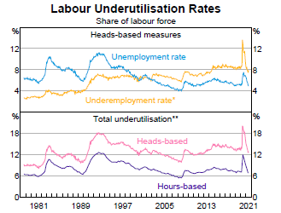 | The decline in both the unemployment rate and the underemployment rate over 2021 means that the labour force underutilization rate has fallen, which indicates a tighter labour market and a decrease in labour market spare capacity. This should start to exert upward pressure on wages and a corresponding increase in spending (AD)/economic growth as well as inflation (on both the demand and supply sides). In this environment, both fiscal and monetary policy are likely to become less expansionary over time. The RBA is less likely to implement more expansionary measures (or more likely to bring forward any tightening of MP) and the government will enjoy an automatic reduction in the budget deficit (i.e. a fall in the cyclical deficit) as well as implement some structural tightening of the budget (e.g. remove some tax concessions and end the provision of some stimulus spending initiatives) which further reduces the (structural) budget deficit.
                            

