Applied Economic Exercise
Read the edited speech by Philip Lowe, RBA Governor, titled ‘The Labour Market and Monetary Policy’ (8 July 2021) and answer the questions that follow.
…When I spoke at this lunch 2 years ago, I talked about the accumulation of evidence that Australia could sustain an unemployment rate below 5 per cent without inflation becoming a problem. I also raised the possibility that the Reserve Bank would soon cut the cash rate to help secure both lower unemployment and inflation consistent with the target. Since then, a lot has happened: a global pandemic and the biggest peacetime economic contraction in our lifetimes; and not only did the RBA cut the cash rate, but we cut it as far as we reasonably could and the RBA's balance sheet has nearly tripled to over $500 billion. So a lot has changed since we last met.
Even so, I would like to return to the same 2 themes that I talked about 2 years ago: first, the possibility of sustaining low rates of unemployment; and second, how the RBA's monetary policy strategy is contributing to this.
I will begin with a brief update on recent labour market developments. I will then discuss the supply side of the labour market and its implications for wage and inflation outcomes. And finally, I will turn to the Reserve Bank Board's decisions earlier this week.

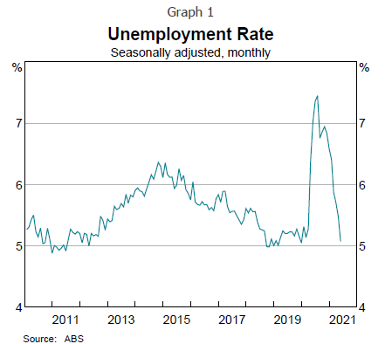
Recent developments
The recovery of the Australian labour market this year has been remarkable. The number of Australians in a job has increased by over 250,000 since the turn of the year and the level of employment is now 1 per cent above its pre-pandemic level. The unemployment rate has also fallen sharply, and is now around the same rate as it was just before the pandemic (Graph 1).
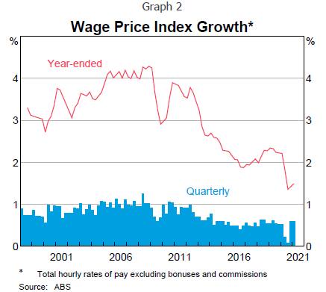
This sharp decline in unemployment has come as a welcome surprise. Back in February, we expected the unemployment rate to now be around 6½ per cent and not reach the low 5s until the second half of 2023. Yet, here we are now. Labour force participation is near its record high, underemployment is the lowest it has been in nearly a decade and job vacancies are at a record high level. These outcomes point to the resilience of the Australian economy and the effectiveness of the health and economic policy response.
One source of uncertainty for the near term is the recent outbreaks of the virus and the lockdowns. We are watching developments carefully, but it is important to remember that Australia's experience has been that, once an outbreak is contained and restrictions are lifted, the economy and jobs bounce back quickly.
It is noteworthy that the positive surprises on jobs have not been matched with equivalent surprises on wages and prices. The Wage Price Index (WPI) increased by just 1½ per cent over the past year and recent outcomes have been broadly in line with our earlier expectations (Graph 2). The same is true for inflation.
…As you would expect, we have been seeking to understand this experience and its implications for our policy settings. One straightforward explanation is that the low wage growth encouraged firms to substitute labour for capital, with the result being that employment grew quickly. The more important part of the story, though, is that the strong growth in labour demand was closely matched by a strong increase in labour supply. With both demand and supply rising, there was little need for the price – that is wages – to move.

The supply side
There are 3 elements of the supply story that I would like to touch on:

- the rise in labour force participation
- the ability of firms to tap into overseas labour markets when workers are in short supply in Australia
- the trend rise in underemployment.

Labour force participation
Labour force participation has been trending up since the middle of the previous decade and is currently around its record high (Graph 5). This upward trend was unexpected, coming after a decade of broadly sideways movement and the ageing of the population. The increase has been particularly large for women. There has also been a rise in participation by Australians older than 55 (Graph 6).

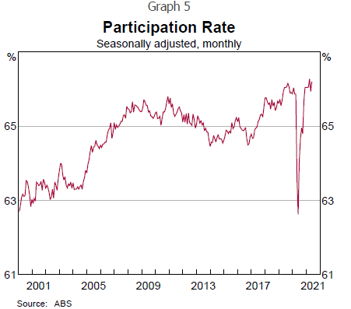 | 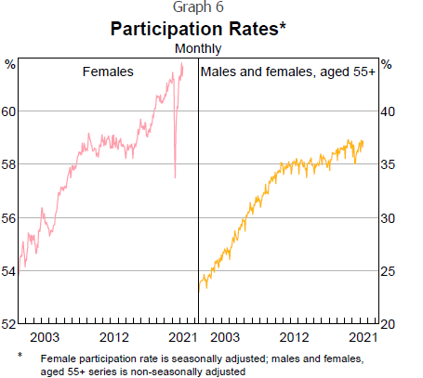

This recent trend reflects a mix of factors, including: the wider availability of flexible and part-time work; changes to child care arrangements; improved health outcomes for older Australians; and changes in the pension age. It is possible that higher debt levels and the decline in asset values during the financial crisis have also played a role.
The most important of these factors is the increased availability of flexible and part-time work, with one in 3 workers now working part time. As hours of work have become more flexible, it has become easier for people with caring responsibilities and older Australians to participate in the paid workforce.
This change has coincided with another shift in the economy – that is, an increase in demand for health services and social assistance, which has led to very strong growth in jobs in these areas. Many of these jobs are able to be performed by people who are seeking part-time and flexible work. So there has been a broadly parallel increase in labour demand and labour supply, and this has lessened the upward pressure on wages.

Drawing on overseas labour markets
The second supply side factor is the ability that firms have had to draw on overseas workers when skills or workers were in short supply in Australia. In some cases, firms hired workers from overseas directly to fill specific gaps, but in other cases they hired people who were already in Australia for other reasons, including to study and on working holidays.
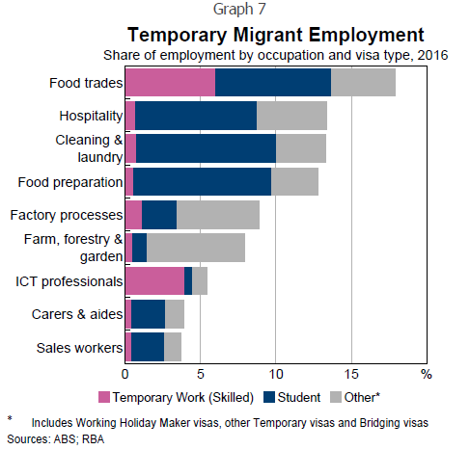
It is useful to distinguish the effects of this ability to draw on overseas labour markets from the impact of immigration more broadly. Immigration adds to both the supply of, and demand for, labour: when immigrants work they supply labour and their consumption of goods and services adds to the demand for labour. The precise balance between this extra labour supply and extra labour demand is difficult to determine and depends upon the specific circumstances.
The picture, though, is clearer when firms are hiring workers to overcome bottlenecks and fill specific gaps where workers are in short supply. This hiring dilutes the upward pressure on wages in these hotspots and it is possible that there are spillovers to the rest of the labour market. This hiring can also dilute the incentive for businesses to train workers to do the required job.
On the positive side of the ledger, hiring overseas workers to overcome bottlenecks allows firms to hire the people they need to operate effectively, and to expand and invest. This benefit was clearly evident during the resources boom, and there are a wide range of businesses and industries that have benefited from hiring foreign workers. Without this ability, output in Australia would have been lower.
At the time of the previous census (in 2016), there were around 430,000 people working in Australia on temporary visas. In the food trades, these workers filled around 18 per cent of all jobs; and in the hospitality sector, they filled 13 per cent of jobs (Graph 7). Most of these workers were on either temporary visas for skilled workers or student visas. In contrast, in the farm sector it was more common for workers to be on working holiday visas.
In conceptual terms, one can think of this ability to tap into the global labour market for workers that are in short supply as flattening the supply curve for these workers. A flat supply curve means that a shift in demand has only a small effect on prices, or in this case wages. In my view, this is one of the factors that has contributed to wages being less sensitive to shifts in demand than was once the case.

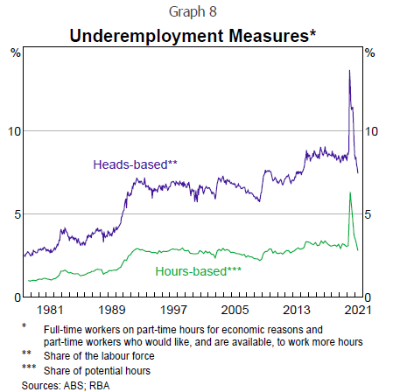
Underemployment
The third element of the labour supply story is underemployment. When somebody is underemployed they are, by definition, willing to supply more labour, generally at the prevailing wage. This means that when demand is strong, businesses are able to call on underemployed workers to supply more hours without much upward pressure on wages. And then, when demand is soft, hours can be scaled back.
Underemployment has become a much more prominent feature of the Australian labour market over the past couple of decades. Today, over 7 per cent of the labour force report that they are underemployed – more than double the rate in the 1980s (Graph 8).
…The rate of underemployment varies significantly across industries and is highly correlated with the share of workers who work part time. For example, the underemployment rate in the accommodation and food services sector is around 20 per cent, while in mining it is less than 1 per cent.
The high rates of underemployment mean that hours of work have become an important margin of adjustment in the Australian labour market. Hours can be scaled up and down when demand changes, rather than the alternative of people being hired and fired. The benefits of this were evident during the pandemic and the financial crisis more than a decade ago. Reflecting this, the RBA has for some time been paying attention to both unemployment and underemployment when assessing the degree of spare capacity in the labour market.

Cost control
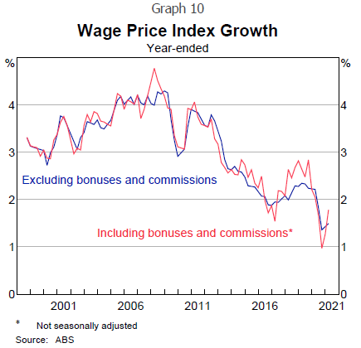
Together, these 3 supply side factors help explain the labour market and wage outcomes over recent times. Strong labour demand was met with a strong supply response. The result was that the price of labour did not move much.
A related factor I have spoken about recently is the laser-like focus on cost control in Australian business over the past decade or so.^{[1]} This focus has made firms wary of increasing wages, lest it hurt their competitiveness in an environment where it is difficult to increase prices. Many have instead relied on non-wage alternatives to attract and retain staff. Higher wages have often been seen as a last resort, especially in an environment where the supply side of the labour market is so flexible.
There has also been a shift by some firms towards variable, as opposed to fixed, remuneration. This has the advantage to the business of avoiding a permanent increase in the cost base, but allowing higher remuneration to be paid for a time. This change is evident in the WPI measure including bonuses, which for most of the available history increased at the same rate as the measure excluding bonuses (Graph 10). But in the second half of the previous decade, the measure including bonuses increased at a faster rate as firms competed for workers.

The outlook
So what does this all mean for the future?
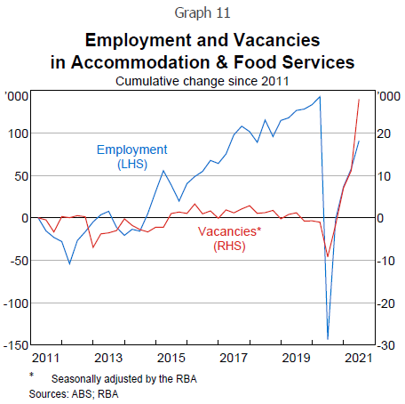
The big change on the supply side has been the closure of our international borders. This has contributed to labour shortages in some areas given the strong pick-up in labour demand. In turn, some workers have received sizeable wage increases. However, the spillover effects to the broader labour market have been limited to date, and wage increases remain modest for most workers. Most firms retain their strong focus on cost control, with many preferring to wait things out until the borders open, and ration output in the meantime.
The impact of this change on the supply side is evident in the sharp jump in the number of job vacancies, especially in the accommodation and food services sector (Graph 11). Whereas previously some of these vacancies could have been filled by people on visas, this is now more difficult to do. Since March 2020, the number of people in Australia on a visa with the right to work has fallen by over 250,000, which is a significant decline.
Given this experience, an important consideration for the outlook is how long the borders remain closed. One plausible scenario is that they open gradually over the period ahead, especially for workers with skills that are in short supply. This would relieve some of the current pressure points in the labour market. Alternatively, it is also possible that the borders remain closed for an extended period and that the pressure points build further. If so, aggregate wages growth would pick up more quickly than currently expected, but production and investment would be also be constrained.
…With all these moving parts, and the uncertainty about the future strength of labour demand, it is challenging to determine exactly when the spare capacity in the labour market will be absorbed and, hence, when we can expect a sustained lift in wages growth. While it is hard to be sure, it is likely that the unemployment rate will need to be sustained in the low 4s for the Australian economy to be considered to be operating at full employment. Underemployment will also need to decline further. To achieve this, a further period of strong employment growth will be required.
…Two of my colleagues at the RBA have examined the relationship between the unemployment rate in nearly 300 individual local labour markets across Australia and the average increase in labour income in these markets using data from the Australian Taxation Office. …The results suggest a clear relationship: the lower unemployment is, the higher is relative income growth. This relationship is stronger when the unemployment rate in a local labour market dips below 5 per cent and strongest when unemployment dips below 4 per cent. While these results are subject to a range of qualifications, they suggest a couple of conclusions. First, tighter labour markets do generate stronger wage increases – the laws of supply and demand still work. And second, the relationship seems to be stronger at unemployment rates below 5 per cent.
These are important conclusions from a policy perspective, especially given the RBA's strategy is to get the unemployment rate down so that wages growth picks up and inflation returns in a sustainable way to the target range.

Monetary policy
This brings me to our monetary policy decisions earlier this week. At our meeting on Tuesday, the Reserve Bank Board agreed to:
- retain the April 2024 bond as the bond for the yield target and retain the target of 10 basis points
- continue purchasing government bonds after the completion of the current bond purchase program in early September. We will purchase $4 billion a week until at least mid November
- maintain the cash rate target at 10 basis points and the interest rate on Exchange Settlement balances of zero per cent.
These measures will provide the continuing monetary support that the economy needs as it transitions from the recovery phase to the expansion phase. They will help lower unemployment and underemployment further and, in time, see inflation return to the 2 to 3 per cent target range. The Board is committed to achieving the goals of full employment and inflation consistent with target.
…In terms of interest rates, the condition that the Board has set for an increase in the cash rate is that inflation is sustainably within the 2 to 3 per cent range. It is not enough for inflation to be forecast in this range. We want to see results before we change interest rates. The bond purchases will end prior to any increase in the cash rate. For inflation to be sustainably in the 2 to 3 per cent range, it is likely that wage growth will need to exceed 3 per cent. That is on the basis that labour productivity continues to increase and that the labour share of national income remains broadly steady. The current rate of wage growth is materially less than 3 per cent. Partly for the reasons I have discussed, we still expect the lift in aggregate wages growth will be gradual. We also expect that it will take until 2024 for inflation to be sustainably within the 2 to 3 per cent target range.
…Thank you for listening. I am happy to answer your questions.

Application/review questions

- Describe the relationship between labour force participation rate, the underemployment rate and job vacancies.
- Explain why the labour force participation rate has increased over times.
- Provide evidence to support the observation that lower unemployment/underemployment has not resulted in wages/inflation.
- Describe some possible explanations for stronger employment growth NOT flowing through to an increase in wages growth. In your response, refer to labour for capital substitution.
- Identify the three supply side factors (or 3 elements of the supply story) that have contributed to slow wages growth in Australia.
- Describe the movement in the participation rate since 2013 and examine the implications for wages growth.
- Explain how each of the following factors have contributed to the change in the participation rate over time:
  - the wider availability of flexible and part-time work;
  - changes to child care arrangements;
  - improved health outcomes for older Australians;
  - changes in the pension age;
  - higher debt levels
- Explain how sourcing offshore labour influences wages growth in Australia.
- Distinguish the impact that immigration has on wages growth compared to sourcing of offshore labour.
- Draw a demand and supply diagram for the labour market and illustrate how the ability to source foreign labour influences the supply curve for labour.
- Using the diagram drawn in the previous question to illustrate, explain how the ability to ‘tap into global labour markets’ influences wages growth in Australia.
- Define underemployment and describe how higher rates of underemployment has influenced wages growth in Australia.
- Define labour market spare capacity and explain why the RBA has been paying attention to both unemployment and underemployment when assessing the degree of spare capacity in the labour market.
- In broad terms, describe the three underlying factors that have prevented the ‘price of labour’ moving much in response to growth in the demand for the labour.
- Explain how a highly competitive global market place may have been a contributing factor behind slow wages growth in Australia.
- Using Graph 10 to illustrate, explain how a shift by some firms towards variable, as opposed to fixed, remuneration may have contributed to lower wages growth.
- Explain how the closure of our international borders is influencing labour market outcomes. Use Graph 11 to illustrate your response.
- The RBA governor noted that ‘ … it is likely that the unemployment rate will need to be sustained in the low 4s for the Australian economy to be considered to be operating at full employment. Explain what this means about both NAIRU and the full employment goal.
- Describe the conditions that will need to be met before the RBA increases the target cash rate. In your response, refer to productivity.

