**Applied Economic Exercise**

**Read** **the edited speech by Philip Lowe, RBA Governor, titled The Recovery, Investment and Monetary Policy (10 March 2021) and answer the questions that follow.**

**The full speech can be accessed here:** <https://www.rba.gov.au/speeches/2021/sp-gov-2021-03-10.html>

Thank you for the invitation to participate in this year's AFR Business Summit and it is great to be here in person. I would like to begin by congratulating the AFR on its 70th anniversary – that is quite an achievement in an industry with so much change. I look forward to many more years of business and finance reporting and analysis.

The timing of this year's summit coincides with a lift in sentiment about the global economy. The rapid development of vaccines and their rollout have improved the global outlook and lessened some of the downside risks. **The plan for further fiscal stimulus in the United States has also improved growth prospects there.** The result has been a reassessment by investors of the outlook for inflation and interest rates around the world.

**…Recent economic and financial developments**

Last week we received further confirmation that the Australian economy is recovering well, and better than expected. GDP increased by 3.1 per cent in the December quarter, following a similar rise in the previous quarter (Graph 1). These back-to-back large increases are materially better outcomes than we expected back in August. They reflect the success that Australia has had on the health front, the very large fiscal and monetary policy support, and the flexibility of Australians in getting on with their lives and businesses. As a result, we are now within striking distance of recovering the pre-pandemic level of output.

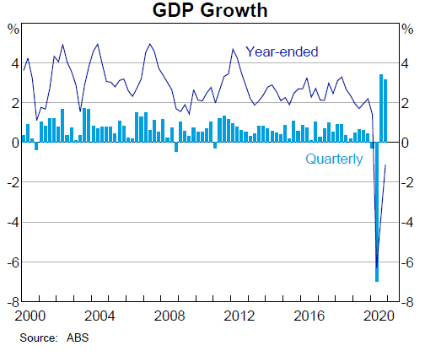Graph 1

There has also been positive news on the employment front over recent months. The **recovery in employment has been V-shaped** and there has been a welcome decline in the unemployment rate to 6.4 per cent (Graph 2). Job vacancies, job ads and hiring intentions remain strong. This suggests that the unemployment rate will continue to trend lower, although **this trend could be temporarily interrupted when JobKeeper** comes to an end later this month.

Graph 2

These better-than-expected outcomes are very welcome news. However, they do not negate the fact that there is still a long way to go and that **the Australian economy is operating well short of full capacity**. There are still many people who want a job and can't find one and many others want to work more hours. And on the nominal side of the economy, we have not yet experienced the same type of bounce-back that we have seen in the indicators of economic activity. For both wages and prices, there is still a long way to go to get back to the outcomes we are seeking. In **underlying terms, inflation is running at 1¼ per cent, and we expect it to remain below 2 per cent over at least the next 2 years** (Graph 3).

Graph 3

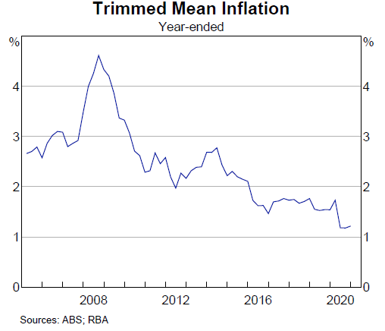

Turning to other countries now, the recent experience has been mixed. A number are benefiting from a pick-up in international trade in goods, following the shift during the pandemic to spending on goods, rather than services. This shift has underpinned stronger conditions in the manufacturing sector, especially in east Asia, and broad-based **increases in commodity prices** (Graph 4). In contrast, in some other countries, virus outbreaks around the turn of the year have interrupted their recoveries.

Graph 4

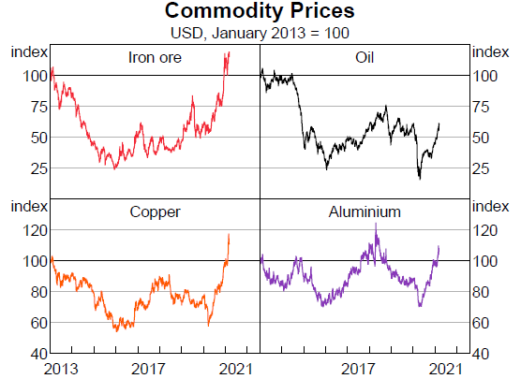

…The lift in inflation expectations is evident in the graph below (Graph 6). For most of the past year, **expected inflation was well below the rates being targeted by central banks. This has now changed and expected inflation has moved to be closer to those targets**. This suggests that investors have more confidence that the policy measures are working to stimulate the global economy and that the recovery will be strong enough to generate inflation close to target. If so, this would be good news. It is also worth noting that expected inflation rates are not especially high and are still not above central bank targets.

Graph 6

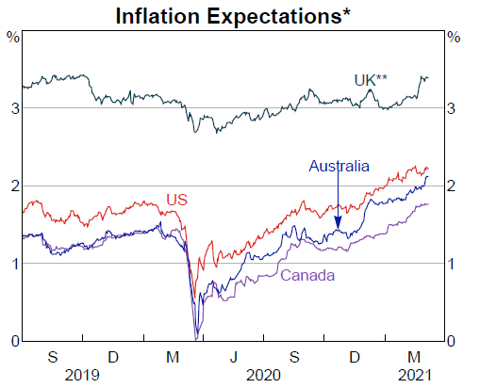

**Investment**

… I would like to focus on one piece of the economic recovery in Australia that has been slow to click into gear: that is, private business investment.

The left-hand side of the next chart shows the RBA's forecast for non-mining business investment prepared in February last year together with the actual outcomes (Graph 8). The right-hand side shows the same for consumption.

Graph 8

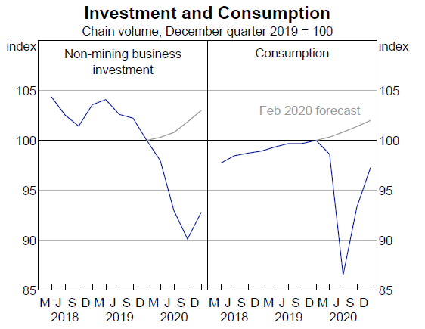

The rebound in consumption has been strong, with growth of 12 per cent over the second half of last year. Investment is a different story. While there was a welcome pick-up in the December quarter, particularly in machinery and equipment investment, investment is still 7 per cent below the level a year earlier and over 10 per cent below where we thought it would be at the start of last year. Non-residential construction is especially weak, with the forward-looking indicators suggesting that this is likely to remain so for a while yet.

This weakness in business investment follows a run of years in which non-mining business investment as a share of nominal GDP was already low by historical standards (Graph 9). Since 2010, this investment ratio averaged 9 per cent, compared with 12 per cent over the previous 3 decades. This is a **material difference and cumulates to slower growth in Australia's capital stock, with implications for our longer-term productive capacity**.

Graph 9

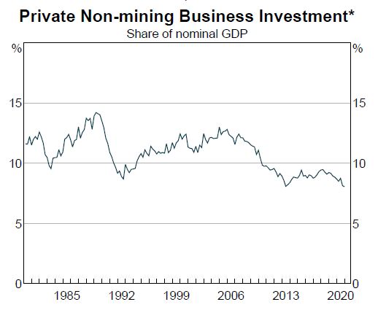

A durable recovery from the pandemic requires a strong and sustained pick-up in business investment. Not only would this provide a needed boost to aggregate demand over the next couple of years, but it would also help build the capital stock that is needed to support future production. **Stronger investment would also support a more productive workforce and a lift in both nominal and real wages**.

Unfortunately, there is no magic ingredient for boosting business investment. A good starting point, though, is businesses having **confidence** that the economy will grow and that there will be demand for their products and services. Another important ingredient is having **stable and predictable regulatory regimes**. **Access to finance** on reasonable terms is also important. To this list, you could add businesses that are able to generate great new ideas and that have the risk appetite and the capability to back these ideas. Having a **highly skilled workforce** and management are obviously important elements here.

**Monetary policy**

…I would now like to return to the outlook for monetary policy in Australia.

Over the past year, **monetary policy has complemented fiscal policy in cushioning the economic effects of the pandemic and in building the bridge to the recovery in economic activity and jobs.** The RBA's policy measures have been keeping financing costs very low, **contributing to a lower exchange rate** than otherwise, supporting the **supply of credit to businesses, and strengthening household and business balance sheets**. In doing so, we have been helping in the national recovery effort.

The Reserve Bank is committed to continuing to provide the necessary assistance and will maintain stimulatory monetary conditions for as long as is necessary. **We want to see a return to full employment in Australia and inflation sustainably within the 2 to 3 per cent target range**. These are our goals and we are committed to achieving them.

An important element of our policy package is the cash rate target being set at what is the **effective lower bound of 0.1 per cent** (Graph 11). The Board will maintain this setting of the cash rate target until inflation is sustainably within the 2–3 per cent range. It is not enough for inflation to be forecast to be in this range. **Before we adjust the cash rate, we want to see actual inflation outcomes in the target range and be confident that they will stay there.** **This is an evolution from the approach earlier in the inflation-targeting regime, in which forecasts of inflation played a more central role in decision-making about interest rates.** We continue to pay close attention to the forecasts, but we want to see actual inflation outcomes consistent with the target before moving the cash rate.

Graph 11

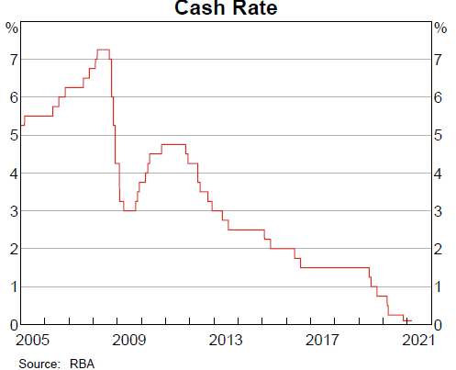

A question that investors have been grappling with recently is when will this condition for a higher cash rate be met? As I discussed earlier, over the past couple of weeks market pricing has implied an expectation of possible increases in the cash rate as early as late next year and then again in 2023. This is not an expectation that we share.

**For inflation to be sustainably within the 2 to 3 per cent range, it is likely that wages growth will need to be sustainably above 3 per cent**. **This is assuming that Australia generates ongoing growth in labour productivity** and that the profit share of national income does not continue to trend higher.

Currently, wages growth is running at just 1.4 per cent, the lowest rate on record (Graph 12). Even before the pandemic, wages were increasing at a rate that was not consistent with the inflation target being achieved. Then the pandemic resulted in a further step-down. This step-down means that we are a long way from a world in which wages growth is running at 3 per cent plus.

Graph 12

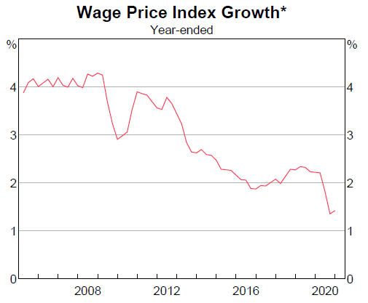

The evidence from both Australia and overseas strongly suggests that **the journey back to sustainably higher rates of wages growth will take time and will require a tight labour market** for an extended period. Prior to the pandemic, multi-decade lows in unemployment rates were recorded in many countries, yet even then there was only a modest lift in wages growth and inflation. And here in Australia, even though unemployment rates in some states fell to levels last recorded in the early 1970s, wage growth remained subdued.

The commonality of experience across advanced countries suggests that there are some **powerful structural factors at work** [to explain the apparent breakdown in the relationship between unemployment rates and wages growth]. These include:

* increased competition in goods markets, which makes firms very conscious of cost increases
* the trend towards more services being provided internationally
* advances in technology, which have reduced the demand for some types of skills and increased the demand for others
* changes to the global supply of labour and regulation of labour markets.

Together, these factors have altered wage and pricing dynamics in almost all advanced economies and these changes are likely to persist. This means that, in the absence of another major shock, **it is a long way back to seeing wage increases consistent with the inflation target**.

Wages, of course, are only one factor influencing inflation outcomes. We will be reminded of this when headline **CPI inflation increases temporarily to around 3 per cent in the June quarter because of the reversal of some pandemic-related price reductions.** Also, there are always relative price shifts occurring due to changes in the balance of supply and demand: recent examples include higher prices for homewares following strong demand during the pandemic and higher prices for meat as farmers rebuild herds after the drought. We will see more such examples as other sectors adjust to the altered balance of supply and demand due to the pandemic. In setting monetary policy, the Reserve Bank Board will look through these transitory fluctuations in inflation.

The point I want to emphasise is that for inflation to be sustainably within the 2–3 per cent target range, wages growth needs to be materially higher than it is currently.

The evidence strongly suggests that this will not occur quickly and that it will require a tight labour market to be sustained for some time. Predicting how long it will take is inherently difficult, so there is room for different views. But our judgement is that we are unlikely to see wages growth consistent with the inflation target before 2024. This is the basis for our assessment that the cash rate is very likely to remain at its current level until at least 2024.

I also want to emphasise that the monetary stimulus is not just about achieving an inflation rate of 2 point something. **It is just as much about achieving the maximum possible sustainable level of employment in Australia**. Unemployment is a major economic and social problem and the Board places a high priority on a return to full employment.

There is, inevitably, some uncertainty about exactly what constitutes full employment in our modern economy. Over the past decade, the estimates of the unemployment rate associated with full employment have been repeatedly lowered both here and overseas. So there is uncertainty. But based on this experience, **it is certainly possible that Australia can achieve and sustain an unemployment rate in the low 4s**, although only time will tell. As we progress towards full employment, we will be relying on the wages and prices data to provide a signal as to how close we are. The current signal is that we are still a long way away from full employment.

…At its recent meetings, the Board has also discussed developments in the housing market, including the rising housing prices across most of the country. There are many moving parts at present: **record low interest rates; a shift in preferences towards houses and away from apartments; strong demand for housing outside our largest cities; large government incentives for first-home buyers and home builders; and the slowest population growth in a century**. Time will tell as to how these various factors ultimately balance out, but history suggests that shifts in population growth can have large effects on the housing market.

I would like to reiterate that the RBA does not target housing prices, nor would it make sense to do so. I recognise that low interest rates are one of the factors contributing to higher housing prices and that high and rising housing prices raise concerns for many people. There are various tools, other than higher interest rates, to address these concerns, leaving monetary policy to maintain its strong focus on the recovery in the economy, jobs and wages.

As part of this focus, we are continuing to pay close attention to lending standards, especially given the combination of low interest rates and rising housing prices. Looser standards would increase medium-term risks and add to the upward pressure on prices, so would be of concern. Reflecting this, the Council of Financial Regulators has indicated that it would consider possible responses should lending standards deteriorate and financial risks increase. We are not at this point, but we are watching carefully.

**Application/review questions**

**Macroeconomy and goals**

1. Explain how further fiscal stimulus in the United States can help to stimulate economic growth in Australia.
2. Analyse Graph 1 and explain why quarterly growth for the second half of 2020 (light blue bars) is positive while annual growth (solid blue line) remains negative.
3. Explain what is meant by the ‘recovery in employment has been V-shaped’. Use Graph 2 to illustrate.
4. Referring to Graph 2, describe the relationship between employment and unemployment. In your response, ensure that you examine the relationship in each direction.
5. Explain whether an increase in employment over any given time period will always be reflected in a lower unemployment rate.
6. Examine how the ending of JobKeeper (a wage subsidy for employers) is likely to impact on the unemployment rate.
7. Explain what it means for the Australian economy to be operating below full capacity. Use an AD/AS diagram to illustrate.
8. Describe two separate indicators that might suggest that the Australian economy is operating well short of full capacity.
9. Describe the trend in the underlying rate of inflation since 2017 and explain why the underlying rate of inflation is currently below the headline rate [for the final quarter of 2020].
10. Explain whether Australia is currently achieving the goal of price stability.
11. Describe the movement in commodity prices over the past year and examine the implications for the goal of full employment.
12. Define ‘inflationary expectations’.
13. Describe the movement in inflationary expectations over the past six months and outline the implications this has for the achievement of price stability.
14. Distinguish Investment demand from Consumption demand, providing examples of each.
15. Referring to Graph 8, explain why Investment and Consumption demand behave differently to the forecasts from February 2020.
16. Describe the recent relationship between Investment, capital stock and productive capacity.
17. Explain the implications for strong and sustainable economic growth of relatively low levels of Investment in the economy.
18. Distinguish nominal wages from real wages.
19. Explain how stronger investment could support a more productive workforce and a lift in both nominal and real wages.
20. Identify some of the conditions needed to boost Investment demand in the economy.

**Policy questions**

1. Broadly describe how monetary policy has complemented fiscal policy in cushioning the economic effects of the pandemic and in building the bridge to the recovery in economic activity and jobs.
2. Explain how a more expansionary monetary policy has contributed to a lower exchange rate and examine how this has influenced economic growth and employment.
3. Explain how a more expansionary monetary policy has supported the supply of credit to businesses, and strengthened household / business balance sheets and examine the implications for inflation.
4. Identify the RBA’s goals as enunciated by the RBA Governor in this speech.
5. Refer to graph 11 and describe the movement in the cash rate over the past two years.
6. Explain what is meant by the target cash rate being at its ‘effective lower bound of 0.1 per cent’.
7. Describe the ‘conditions’ required before the RBA will increase the target cash rate and explain how these ‘çonditions’ differ to those required in the past.
8. Explain why the Covid-19 pandemic ultimately triggered a further decline in wages growth.
9. Describe the relationship between wages growth and monetary policy settings and discuss the role of productivity growth in influencing the nature of this relationship.
10. Define ‘tight labour market’ and describe the relationship between wages growth and a tight labour market.
11. Discuss the extent to which the unemployment rate has become a better or worse indicator of tightness within labour markets. In your answer, make reference to at least one of the ‘powerful structural factors at work’ that are referred to in the speech.
12. Explain why the RBA believes that ‘it is a long way back to seeing wage increases consistent with the inflation target’.
13. Explain why the ‘expected increase’ in headline inflation above 3% for the June quarter 2021 will not result in a tightening of monetary policy.
14. Describe the RBA’s justification for the maintenance of an expansionary monetary policy stance at the current time.
15. Given that the RBA believes that it is possible to achieve and sustain an unemployment rate in the low 4s, outline the implications this has for the ‘goal of full employment’.
16. List some of the conditions influencing Australia’s housing market at the present time and outline the impact that each is expected to have on housing prices.
17. The RBA will not tighten monetary policy to reduce house prices. Discuss.
18. Explain whether the RBA Governor’s musings about the housing market has the potential to influence economic activity and/or investment in the housing market.