Applied Economic Exercise
For members of www.economicstutor.com.au

Watch the video clip at the following link https://www.youtube.com/watch?v=wV1qI0Xg2z0 and answer the questions that follow:

- Explain why the coronavirus is considered both a demand and a supply shock to Australia’s economy.

__________________________________________________________________________________________________

__________________________________________________________________________________________________

__________________________________________________________________________________________________

__________________________________________________________________________________________________

__________________________________________________________________________________________________

- Identify two major industries suffering disproportionally from the impacts of the virus.

__________________________________________________________________________________________________

__________________________________________________________________________________________________

- Use the AD/AS diagram below to model and explain the impact of the virus on economic growth and inflation.

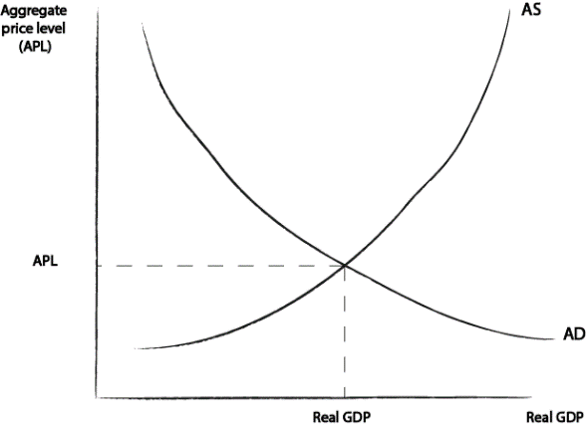
______________________________________________________

______________________________________________________

______________________________________________________

______________________________________________________

______________________________________________________

______________________________________________________

- Explain what is meant by the claim that ‘the structure of our labour market means that there is an immediate transmission mechanism to household budgets’. In your answer refer to Australia’s casualised workforce, particularly in the hospitality industry.

__________________________________________________________________________________________________

__________________________________________________________________________________________________

__________________________________________________________________________________________________

__________________________________________________________________________________________________

__________________________________________________________________________________________________

__________________________________________________________________________________________________

__________________________________________________________________________________________________

__________________________________________________________________________________________________

- Explain how the government stimulus measures (such as financial support for businesses and households) will impact on economic growth and the achievement of full employment.

__________________________________________________________________________________________________

__________________________________________________________________________________________________

__________________________________________________________________________________________________

__________________________________________________________________________________________________

__________________________________________________________________________________________________

__________________________________________________________________________________________________

- Explain how the income and living standards of self-employed contractors and workers in the ‘gig economy’ are particularly affected by the virus.

__________________________________________________________________________________________________

__________________________________________________________________________________________________

__________________________________________________________________________________________________

__________________________________________________________________________________________________

- Describe the relationship between ‘declining economic activity’ and the ‘stability of financial markets’. In your answer, highlight the important link to labour markets and debt serviceability, as well as debt servicing costs for Australian banks relying on offshore funding.

__________________________________________________________________________________________________

__________________________________________________________________________________________________

__________________________________________________________________________________________________

__________________________________________________________________________________________________

__________________________________________________________________________________________________

__________________________________________________________________________________________________

__________________________________________________________________________________________________

__________________________________________________________________________________________________

__________________________________________________________________________________________________

__________________________________________________________________________________________________

__________________________________________________________________________________________________

- Explain how ‘the fear of the coronavirus itself’ is perhaps a bigger potential shock to the economy than the virus itself. In your answer, refer to the one of the AD factors affecting economic activity.

__________________________________________________________________________________________________

__________________________________________________________________________________________________

__________________________________________________________________________________________________

__________________________________________________________________________________________________

__________________________________________________________________________________________________

__________________________________________________________________________________________________

- Discuss whether the Australian economy will experience a recession in 2020.

__________________________________________________________________________________________________

__________________________________________________________________________________________________

__________________________________________________________________________________________________

__________________________________________________________________________________________________

- Since the production of the video, the Australian government has announced the delivery of an unprecedented $130 billion wage subsidy paid to employers [https://treasury.gov.au/coronavirus] Explain how this subsidy:

  - Is designed to protect economic growth

________________________________________________________________________________________

________________________________________________________________________________________

________________________________________________________________________________________

________________________________________________________________________________________

  - Is expected t impact on the achievement of full employment

________________________________________________________________________________________

________________________________________________________________________________________

________________________________________________________________________________________

________________________________________________________________________________________

  - Will influence the budget deficit and government debt

________________________________________________________________________________________

________________________________________________________________________________________

________________________________________________________________________________________

________________________________________________________________________________________

  - Impact on ‘future’ rates of economic growth.

________________________________________________________________________________________

________________________________________________________________________________________

________________________________________________________________________________________

________________________________________________________________________________________

