Applied economic exercise
economicstutor.com.au
April 2020

Read the (heavily edited) speech from the RBA Governor titled’ An Economic and Financial Update’ and answer the questions that follow. The speech (and questions) have been edited with a focus on content related to VCE Economics Unit 3. Those elements of the speech relating to a more in depth understanding of monetary and fiscal (budgetary) policy have been edited out or modified for simplicity. The unedited speech can be accessed here: https://www.rba.gov.au/speeches/2020/sp-gov-2020-04-21.html

The Economic Outlook

… I would like to focus on two broad issues:

- the immediate outlook for the economy
- the nature and speed of the recovery.

…One very obvious consequence of the efforts needed to contain the virus is that many normal activities are restricted or not permitted. This means that, for as long as these restrictions are in place, we don't have the jobs and incomes that come from these activities. On top of this, there is a high level of uncertainty about the future, which means that many households and businesses are holding back their spending and investment.

The result of both the restrictions and the uncertainty is that over the first half of 2020 we are likely to experience the biggest contraction in national output and income that we have witnessed since the 1930s.

Putting precise numbers on the magnitude of this contraction is difficult, but our current thinking is along the following lines:

- National output is likely to fall by around 10 per cent over the first half of 2020, with most of this decline taking place in the June quarter.
- Total hours worked in Australia are likely to decline by around 20 per cent over the first half of this year.
- The unemployment rate is likely to be around 10 per cent by June, although I am hopeful that it might be lower than this if businesses are able to retain their employees on lower hours. The unemployment rate would have been much higher than this without the government's JobKeeper wage subsidy.

…In terms of inflation, we are also expecting a significant decline in the June quarter. The large fall in oil prices, combined with the introduction of free childcare and the deferral or reduction in some price increases mean that it is quite likely that year-ended headline inflation will turn negative in June. If so, this would be the first time since the early 1960s that the price level has fallen over a full year. In underlying terms, however, inflation is expected to remain positive.

Inevitably, the timing and pace of this recovery depend upon how long we need to restrict our economic activities, which in turn depends on how effectively we contain the virus. …One plausible scenario is that the various restrictions begin to be progressively lessened as we get closer to the middle of the year, and are mostly removed by late in the year, except perhaps the restrictions on international travel.

Under this scenario we could expect the economy to begin its bounce-back in the September quarter and for that bounce-back to strengthen from there. If this is how things play out, the economy could be expected to grow very strongly next year, with GDP growth of perhaps 6–7 per cent, after a fall of around 6 per cent this year. There is though quite a lot of uncertainty around the numbers, with the exact profile of the recovery depending not only upon when the restrictions are lifted but also on the resolution of the uncertainty that people feel about the future.

…It is likely that the unemployment rate will remain above 6 per cent over the next couple of years. With many firms delaying or cancelling wage increases, year-ended wage growth is expected to decline to below 2 per cent, before gradually picking up again. In underlying terms, inflation is expected to remain below 2 per cent over the next couple of years.

Of course, there are other scenarios as well. On the optimistic side, the restrictions could be lifted more quickly, with the virus being contained. In that case, a stronger recovery could be expected, particularly in light of the very large monetary and fiscal support that is in place. On the other hand, if the restrictions stay in place longer, or they have to be reimposed, the recovery will be delayed and interrupted. In that case, the loss of incomes and jobs would be even more pronounced.

…It is highly probable that the severe shocks we are now experiencing will change the mindsets of some people and businesses. Even after the restrictions are lifted, it is likely that some of the precautionary behaviour will persist. And in the months ahead, we are likely to lose some businesses, despite best efforts, and some of these businesses will not reopen. There will also be a higher level of debt and some households might revaluate the risks of having highly leveraged balance sheets. It is also probable that there will be structural changes in the economy. We are all learning to work, shop and travel differently. Some of these changes will probably stay with us, requiring a rethinking of business models. So the crisis will have reverberations through our economy for some time to come.

… A strong focus on making Australia a great place for businesses to expand, invest, innovate and hire people is the best way of extending the recovery into a new period of strong and sustainable growth and rising living standards for all Australians.

The Reserve Bank's Policy Response

I would now like to change tack and turn to the Reserve Bank's policy response. [The RBA has implemented a]… comprehensive package [that is] designed to keep funding costs low across the economy [i.e. reduce interest rates] and ensure credit is available to businesses and households. …This package, combined with the government's fiscal policies and the work of the banks and many businesses, is building that strong bridge [to economic recovery] that I have spoken about.

Our monetary response is keeping funding costs low across the economy and credit available. The fiscal response is providing significant support to both jobs and incomes. Businesses are also helping their employees by keeping them on where they can and the banks are supporting their customers with more flexible terms. Together, these efforts are helping the Australian economy through a difficult period and positioning us well for the recovery.

Application/review questions

- Explain what is meant by a contraction of national output.
________________________________________________________________________________________
________________________________________________________________________________________
- Refer to the circular flow model of income below to describe how the coronavirus is expected to result in a contraction in national output. In your response, use the following bolded terms referred to in the early part of the RBA Governor’s speech: jobs, hours worked, incomes, spending and investment, national output, unemployment.
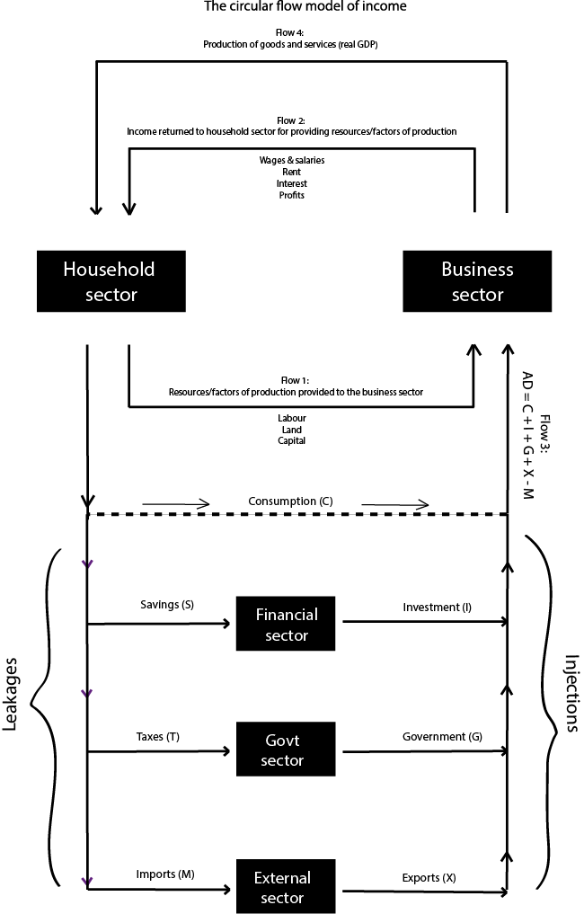
________________________________________________________________________________________
________________________________________________________________________________________
________________________________________________________________________________________
________________________________________________________________________________________
________________________________________________________________________________________
________________________________________________________________________________________
________________________________________________________________________________________
- Use the demand/supply diagrams below to illustrate:
  - the impact of the coronavirus on product markets (e.g. the market for goods) and the labour market (i.e. the market for labour).
  - the impact of a wage subsidy on product markets and the labour market (i.e. the market for labour).
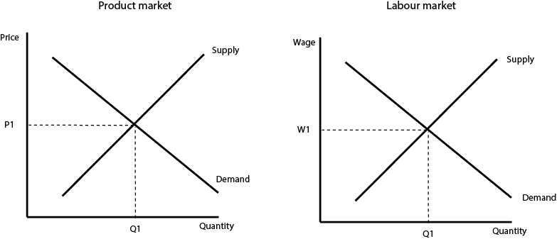
- Explain how the wage subsidy is expected to impact on each of the following:
  - The unemployment rate
  - The underemployment rate
  - The participation rate
  - The labour force underutilization rate

- Outline why lower oil prices and free childcare are expected to contribute to a lower rate of inflation. Analyse the implications that might have for the achievement of price stability.
________________________________________________________________________________________
________________________________________________________________________________________
________________________________________________________________________________________
________________________________________________________________________________________
________________________________________________________________________________________
________________________________________________________________________________________
________________________________________________________________________________________
________________________________________________________________________________________
________________________________________________________________________________________
________________________________________________________________________________________
________________________________________________________________________________________
________________________________________________________________________________________
________________________________________________________________________________________
________________________________________________________________________________________

- Identify the term used to describe a negative rate of inflation.
________________________________________________________________________________________

- Explain why a negative rate of headline inflation can be consistent with a positive rate of underlying inflation.
________________________________________________________________________________________
________________________________________________________________________________________
________________________________________________________________________________________
________________________________________________________________________________________
- Describe some factors that will ultimately determine ‘the pace of recovery’ from the expected economic contraction.
________________________________________________________________________________________
________________________________________________________________________________________
________________________________________________________________________________________
________________________________________________________________________________________
- Explain why nominal wages growth is expected to be very low over the next two years and discuss whether this will lead to a reduction in real wages.
________________________________________________________________________________________
________________________________________________________________________________________
________________________________________________________________________________________
________________________________________________________________________________________
________________________________________________________________________________________
________________________________________________________________________________________
________________________________________________________________________________________
________________________________________________________________________________________
- Briefly identify the fiscal support put in place by the Government to support the economy.
________________________________________________________________________________________
________________________________________________________________________________________
________________________________________________________________________________________
________________________________________________________________________________________

- Outline how the Government fiscal support (referred to in the previous question) might have the potential to constrain future rates of economic growth.
________________________________________________________________________________________
________________________________________________________________________________________
________________________________________________________________________________________
________________________________________________________________________________________
________________________________________________________________________________________
________________________________________________________________________________________
- Identify what the RBA Governor means when he says that:
  - some households might revaluate the risks of having highly leveraged balance sheets; and
  - there will be structural changes in the economy.
________________________________________________________________________________________
________________________________________________________________________________________
________________________________________________________________________________________
________________________________________________________________________________________
________________________________________________________________________________________
________________________________________________________________________________________
________________________________________________________________________________________
________________________________________________________________________________________
________________________________________________________________________________________
________________________________________________________________________________________
________________________________________________________________________________________
________________________________________________________________________________________
- Describe how the RBA’s response to the economic crisis is expected to assist with economic recovery. In your response, refer to jobs and incomes.
________________________________________________________________________________________
________________________________________________________________________________________
________________________________________________________________________________________
________________________________________________________________________________________
________________________________________________________________________________________
________________________________________________________________________________________
________________________________________________________________________________________
________________________________________________________________________________________

