Applied Economic Exercise
For members of www.economicstutor.com.au

Watch the video clip produced by ‘The Economist’ at the following link and answer the questions that follow https://www.youtube.com/watch?v=wUUWoN4LKuE:

- Explain why the coronavirus has caused the price of ‘commodities’ to fall and examine the implication for Australia as a major commodity exporter.

__________________________________________________________________________________________________

__________________________________________________________________________________________________

__________________________________________________________________________________________________

__________________________________________________________________________________________________

__________________________________________________________________________________________________

- Explain how and why stockmarkets around the world have reacted to the spreading of the virus.

__________________________________________________________________________________________________

__________________________________________________________________________________________________

__________________________________________________________________________________________________

__________________________________________________________________________________________________

- Compare the impacts of the coronavirus with the ‘burst of the dot.com bubble’ in 2000 and 2007-9 financial crisis and explain why the effects of the coronavirus have been relatively dramatic in comparison.

__________________________________________________________________________________________________

__________________________________________________________________________________________________

__________________________________________________________________________________________________

__________________________________________________________________________________________________

- Identify those industries that have been hardest hit by the economic effects of the coronavirus. In your answer, refer to costs (or expenses), revenue and profit.

__________________________________________________________________________________________________

__________________________________________________________________________________________________

__________________________________________________________________________________________________

__________________________________________________________________________________________________

__________________________________________________________________________________________________

- Explain how ‘lockdowns’ are having a ‘devastating ripple effect’ even on those businesses not directly impacted by ‘people staying at home’. In your answer, refer to ‘supply chains’.

__________________________________________________________________________________________________

__________________________________________________________________________________________________

__________________________________________________________________________________________________

__________________________________________________________________________________________________

- It is generally accepted that most economies around the world will experience a recession in 2020 but what remains uncertain is whether the recession will be ‘V-shaped recession’, a ‘U-shaped recession’ or an ‘L shaped recession’. Define a ‘recession’ and distinguish between the three types of recessions. Use the diagram below to illustrate the differences.
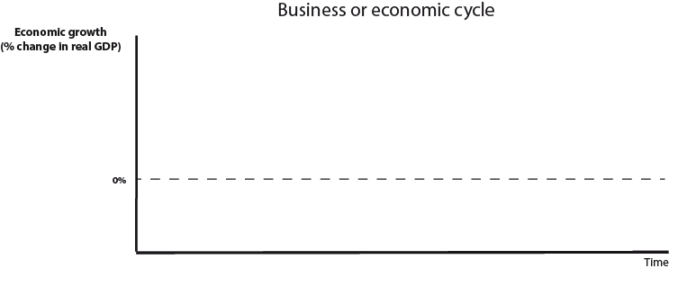
- Based on the relative success of China’s effort to control the spread of the virus, examine the implications for the type of recession likely to experienced by China and (hopefully) other economies.

__________________________________________________________________________________________________

__________________________________________________________________________________________________

__________________________________________________________________________________________________

- Briefly describe how foreign governments have attempted to address the negative economic impacts of the coronavirus and discuss the likely success (or otherwise) of these measures.

__________________________________________________________________________________________________

__________________________________________________________________________________________________

__________________________________________________________________________________________________

- Discuss the inherent conflict between ‘measures to reduce the economic effects of the virus’ with ‘measures to save lives’.

__________________________________________________________________________________________________

__________________________________________________________________________________________________

__________________________________________________________________________________________________

